ICPS2024 Conference Arrival Guidance

Dear Delegates,

Thank you for registering for the International Conference of Physiological Sciences, which will take place at the Hongdao International Conference & Exhibition Center in Qingdao from August 22nd to 25th, 2024. Below, you will find important notices and information to ensure your easy arrival and stay in Qingdao. We recommend keeping this document with you throughout the conference.

- Airport – Arrival Guidance
Most flights arrive at Qingdao Jiaodong International Airport, located 39 kilometers from the city center.

By Subway
Take line 8 from the Airport and get off at “Fitness Center Station (Hongdao Exhibition Center Station)”. Then take the exit E out, and you’ll see the Hotel directly in front of you, and the registration venue is less than 50 meters away. The entire subway ride will take approximately 35 minutes and costs CNY 5 per person, one way.

By Taxi
The airport is approximately 22 kilometers from the venue, and the journey to the registration venue will take about 25 minutes, costing around CNY 60. This option is strongly recommended for first-time visitors. You can show the following note to the taxi driver for assistance.
TAXI NOTE
司机师傅您好，请送我去红岛国际会议展览中心，谢谢！
地址 (Chinese Address)：
中国青岛高新区火炬路326号

2. Transportation in Qingdao

Subway
Qingdao’s subway system consists of 8 lines, operating from 05:30 AM to 23:05 PM. Tickets can be purchased at each station’s ticket office or through an automated ticket machine. The base fare is CNY 2, with additional charges applied for longer distances.

Taxi
Taxis in Qingdao come in various colors, all equipped with a taximeter. They are readily available throughout the city. The base fare is CNY 10, with additional charges for longer trips.
Alternatively, you can use various taxi-hailing apps, which offer a range of pricing options and automatically calculate the fare.

3. Conference Registration Onsite

Registration Desk
Registration and Information Desks will be located at the Costal Tower of Hongdao International Conference & Exhibition Center on the following days and times:

August 22, 2024 | 10:00-20:00
August 23, 2024 | 08:00-18:00
August 24, 2024 | 08:00-18:00
August 25, 2024 | 08:00-12:00

For any inquiries related to registration, social events, or other conference details, please do not hesitate to approach our staff at the registration desk. Participants can also collect their conference bags, badges, lunch and welcome reception tickets, as well as the conference program & materials from the registration desk.

Registration Fees

Categories | Onsite Registration  (On/After August 1, 2024)
Members | CNY 2300
Non-Members | CNY 2500
Student Members | CNY 1500
Student Non-Members | CNY 1700

The Flow of Registration
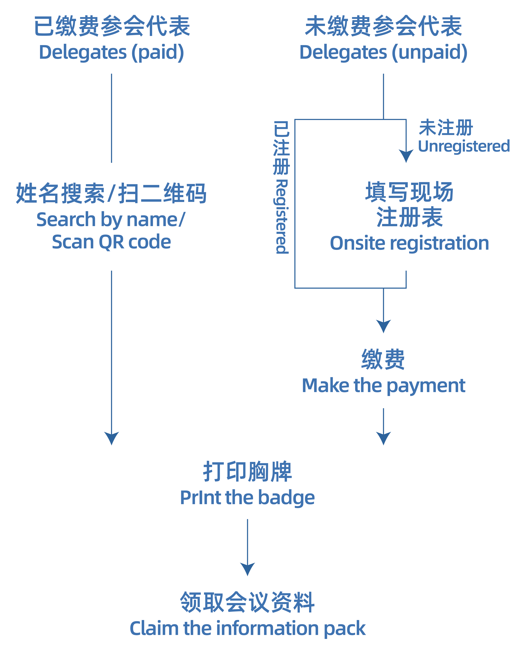

Upon arriving at the registration area, please provide your name as used for online registration to one of the staff members stationed there or you can scan the QR code displayed at the registration desk to check your registration status.
Items to be collected during registration

- Name Badge with Lunch Tickets, and Welcome Reception Ticket
- Conference Program & Materials
- Stationary (Pen & Notebook)
- Conference Bag

4. PowerPoint Collection

The Slide Preview Room will be situated next to the registration desk and will be open during the same hours as the registration desk.:

August 22, 2024 | 10:00-20:00
August 23, 2024 | 08:00-18:00
August 24, 2024 | 08:00-18:00
August 25, 2024 | 08:00-12:00

All speakers must visit to the Slide Preview Room with a copy of their presentation materials (Microsoft PowerPoint files) to verify compatibility with the conference equipment and to ensure the presentation is transferred to the conference computers. Speakers are encouraged to upload their PowerPoint onto one of the computers in the Slide Preview Room at least three hours before their session starts. Presenters with morning sessions are highly recommended to upload their PowerPoint files the day before.
5. Poster Display Setup

Presenters who bring their own printed posters should locate the on-site staffs available at the poster boards to put up their posters. Tape and scissors will be provided for your convenience.

